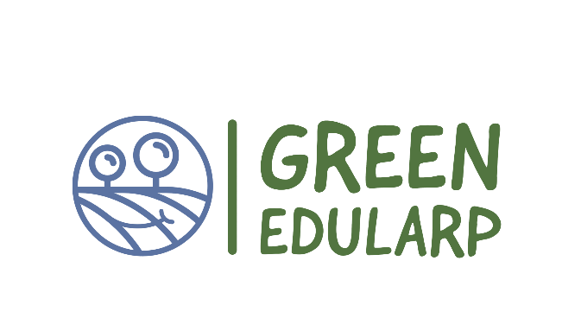

Newsletter 3

December 2022

GreenEduLARP first implementation year is almost done
The GreenEdu Larp project's first year is almost done. During the first months, the project team prepared a mapping of EduLARPs’ situation and educational contexts in Estonia, Greece, Sweden, Polan. During this period Project. A project web page has launched and newsletters were prepared.
More intensive work is waiting for the project team next year, when The 3-days GEL training workshop will be held in Mełgiew in Poland. During the workshop, the different elements of the GEL Curriculum, teachers’ toolkit, AV Hub and Strategy will be presented and explained. The workshop will be chaired by LV and NP and facilitated by expert trainers from partner organisations.
Activities briefly done so far in the third period.
- GreenEduLARP curriculum is ready!
- Global education platform meeting in Estonia.
- Newsletters developed and disseminated.
- Development of Greed Edu Larp lesson plans and toolkit.

The GreenEduLARP curriculum is ready!
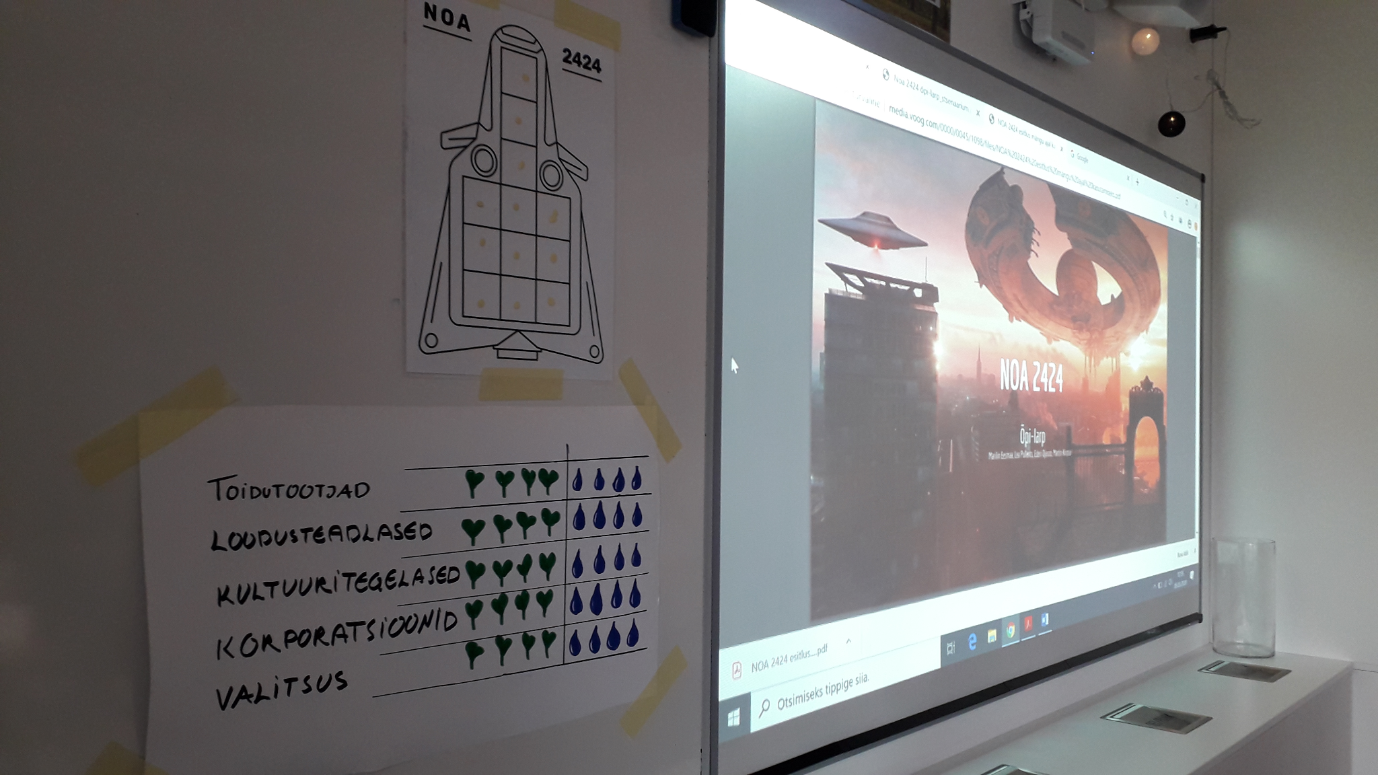
The GreenEduLarp (GEL) curriculum provides experiences for students to develop the necessary skills (i.e. agency, creative thinking, interpersonal skills, problem solving) that will transform them into creative and critical thinkers and progressively green changemakers.
The GEL curriculum introduces EduLARP (Educational Live Action Role Playing) as a means to act for climate change in schools.
From raising awareness on environmental issues (knowledge acquired) towards concrete actions of primary and secondary education students. The GEL aspires to foster problem solving for climate change and critical thinking, creativity and teamwork competences as well as shift students’ mindset towards taking action against environmental problems in their community while developing soft skills and confidence.
GreenEduLarp met the “Larp for Climate” project at Krakow
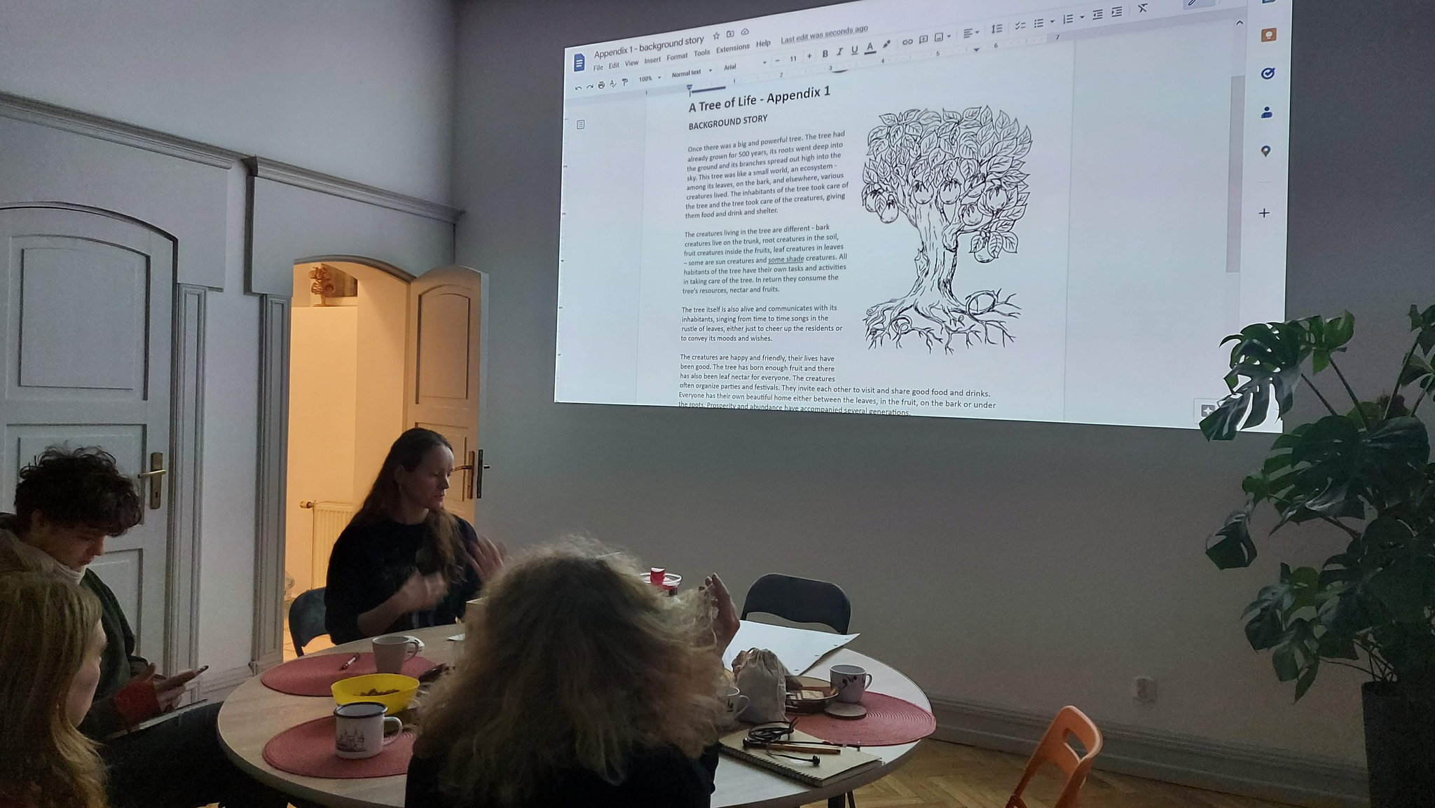
Peipsi Center for Transboundary Cooperation and some more participants from Estonia visited "Larp For Climate - an adaptation of eduLarp methodology to learning agenda for climate literacy" design and testing seminar in Nausika Hub in Kraków 14-19.11.2022. During the project management meeting also possible cooperation between the projects were discussed.

Global education platform meeting in Estonia
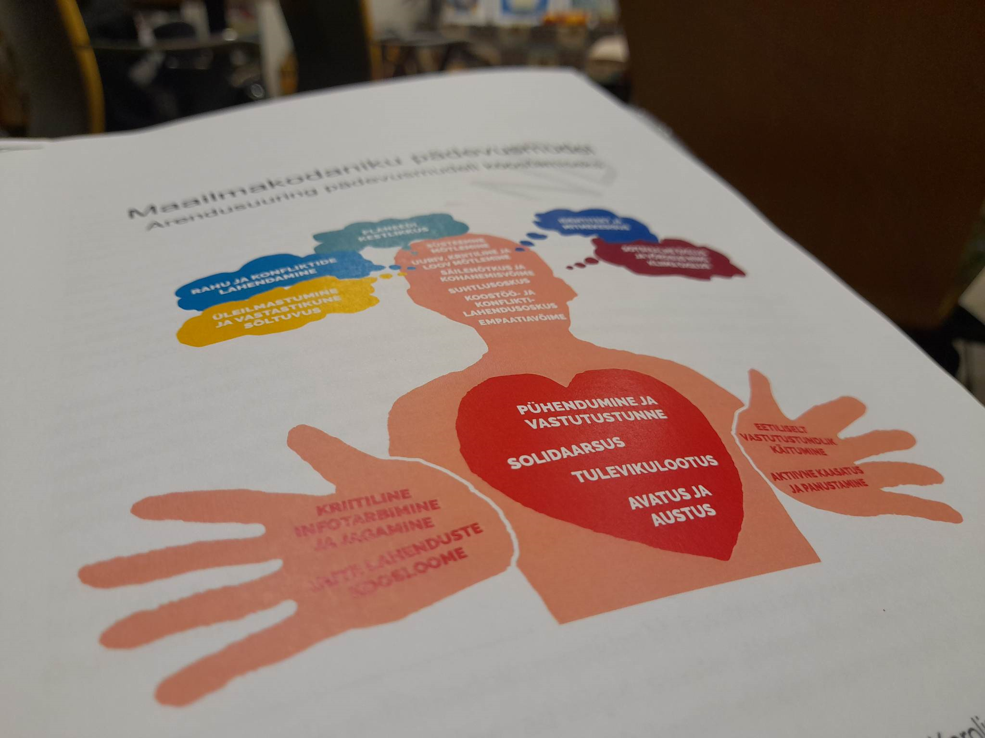
On December 14 a meeting of the global education platform was held in Estonia. At the meeting the goals of the field of global education in 2023 and beyond were discussed. The meeting was attended by the Ministry of Foreign Affairs, EstDev, NGOs and educational institutions. It was an important sectoral discussion following the adoption of the World Education Declaration in Dublin last month. Peipsi Center for Transboundary Cooperation presented the idea of using edu-larp as a tool for talking about global and environmental education at schools in Estonia.

Upcoming events:
- Peipsi Center for Transboundary Cooperation will introduce the GEL curriculum in the teachers training organised by NGO Mondo in Estonia.
- Stimmuli for Social Change is organising online event “School Education for Greener Futures” within the framework of Learning Planet Festival 2023, where also GreenEduLARP will be introduced.
- Green EduLarp project LLTA and TPM will be held from the 26th to 30th April in Poland
- In September 2023 the project will be a part of a local Environmental awareness week in Sweden.

